**ASCO VALVE CANADA INTRODUCES NEW RED HAT VALVE**

With headquarters located in Brantford, Ontario, ASCO Valve Canada is one of Canada’s top producers of solenoid valves. The company was founded in 1965, and since that time it has emerged as a very successful industrial company that currently employs 75 people across Canada. ASCO offers an array of products to its clients. These products range from valves that are used in the gas pipeline industry to valves that are used in medical procedures.

One of ASCO’s goals was to develop a valve that could minimize the cost to consumers, including cost of operations and the amount of power consumed. In 2005, ASCO achieved its goal by developing and introducing its new Red Hat Next Generation valves. Today, these valves are well recognized and respected in many different countries due to their exceptional performance in difficult conditions. These valves are also very energy efficient because they are able to use a mere 2 watts of power rather than the 17 watts of power that the typical solenoid valves use. This is a very important cost benefit for any company using valves because these new products can decrease the total cost of ownership by almost 14% over the installed life of the valve.

The Red Hat Next Generation valves have many advantages, for example, (1) better and more reliable functionality, (2) reduced usage of power, and (3) modular design. These advantages have allowed ASCO to provide consumers with better quality valves at reasonable prices and ensure fast delivery. Recently, ASCO has made it very clear that one of its objectives was to reduce lead times in order to satisfy customer demand. Within a short period of time, it has already accomplished this and can deliver products to its customers at a much faster rate.

**Discussion**

1. The new Red Hat Next Generation valves are durable and reliable. They can operate with high air pressure of up to 2,200 psi (pounds per square inch). Suppose ASCO develops a new and stronger version of the Red Hat Next Generation valve, they want to set up an experimental design to test the strength of the new valve, but they want to conduct the tests under three different temperature conditions, 23oC, 49oC, and 68oC. In addition, suppose ASCO uses two different suppliers (supplier 1 and supplier 2) for the synthetic materials that are used to manufacture the valves. Some valves are made primarily of raw materials supplied by supplier 1, and some are made primarily of raw materials from supplier 2. Consequently, a 2 x 3 factorial design is appropriate for the experiment, with temperature and supplier as the independent variables and air pressure (measured in psi) as the dependent variable. An appropriate sampling frame has produced the data shown below. Analyze the data and discuss the business implications of the findings. If you were conducting the study, what conclusions would you report to the company?

|  |  |  |  |
| --- | --- | --- | --- |
|  | **Temperature** | | |
|  | **23oC** | **49oC** | **68oC** |
|  | 2,257 | 2,207 | 2,201 |
| ***Supplier 1*** | 2,479 | 2,491 | 2,173 |
|  | 2,361 | 2,314 | 2,192 |
|  | 2,215 | 2,230 | 2,229 |
| ***Supplier 2*** | 2,308 | 2,359 | 2,088 |
|  | 2,511 | 2,488 | 2,287 |

1. It is estimated that these Red Hat energy-efficient valves can save a great deal of power usage and lower the total cost of ownership by up to 14% over the installed life of the valve, therefore making the Red Hat valves more attractive. ASCO does business with pipeline companies globally. In an attempt to position itself as a market leader across the world, ASCO is keen on finding out whether the cost saved over the installed life of the valve is significantly different among the different countries in which it does business. Four countries, Canada, Spain, Japan and United States, are chosen for the study. Pipeline companies are selected from each country. The companies keep a log of valve power usage. A random sample of the data is shown below. Test whether there is a difference in relative cost savings in each of these countries. Justify your answer and prepare a short report to present to the management of ASCO in which your conclusions are explained, with support from the statistical test that you performed.

|  |  |  |  |
| --- | --- | --- | --- |
| **Canada** | **Spain** | **Japan** | **U.S.** |
| 12% | 9% | 14% | 13% |
| 14 | 10.5 | 14 | 12.5 |
| 11.5 | 11 | 13 | 14 |
| 10 | 14 | 13.5 | 11.5 |
| 14 | 8.5 | 12 | 14 |
| 13 | 12 | 12.5 | 13 |

1. As previously mentioned, ASCO has been able to reduce its lead time. suppose ASCO’s original lead time average 10 weeks and that the reduction is in the neighborhood of 80%. As such, most lead times now average slightly below two weeks. ASCO is interested in knowing whether lead times differ significantly according to the type of Red Hat valve it is manufacturing. To control the experiment, they will use as a blocking variable the day of the week the valve was ordered. One lead time was selected per valve per day of the week. The sample data are given below in weeks. Analyze the data and discuss your findings.

|  |  |  |  |
| --- | --- | --- | --- |
|  | ***Type of Red Hat Valve*** | | |
|  | ***Two-way*** | ***Three-way*** | ***Four-way*** |
| Monday | 1.7 | 1.9 | 2.2 |
| Tuesday | 1.9 | 1.8 | 1.9 |
| Wednesday | 1.0 | 2.3 | 2.4 |
| Thursday | 1.4 | 1.5 | 1.8 |
| Friday | 2.1 | 2.0 | 2.5 |

1.

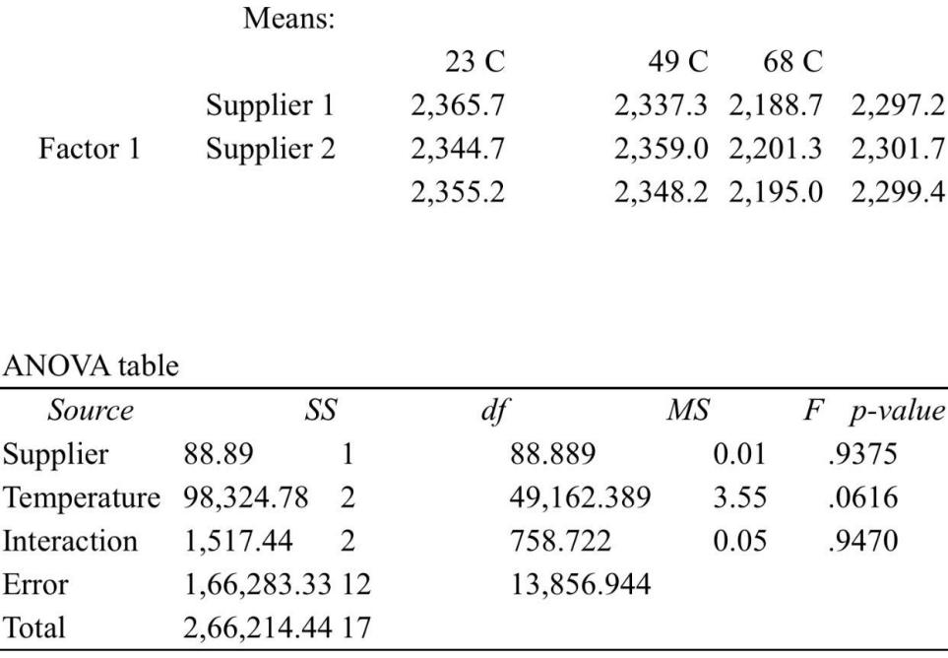

The hypothesis being tested is:

H0:There is no main effort of supplier

Ha:There is a min effort of supplier the p-value is 0.9375.

Since the p-value(0.9375)is greater than the significance level(0.05),we fail to reject the null hypothesis.

Therefore we cannot conclude that there is a main effort of supplier.

The hypothesis being tested is:

H0:There is no main effort of temperature

Ha:There is a main effort of temperature the p-value is 0.0616.

Since the p-value (0.0616)is greater than the significance level (0.05)we fail to reject the null hypothesis.

Therefore we cannot conclude that there is a main effort of temperature.

The hypothesis being tested is:H0:There is no interaction effort

Ha:There is an interaction effort the p-value is 0.9470

Since the p-value(0.9470)is greater than the significance level(0.05)we fail to reject the null hypothesis.

Therefore we cannot conclude that there is an interaction effort.

Thus we values are not reliable.

2.Answer

|  |  |  |  |  |
| --- | --- | --- | --- | --- |
|  | **Canada** | **Spain** | **Japan** | **U.S.** |
|  | 12% | 9% | 14% | 13% |
|  | 14 | 10.5 | 14 | 12.5 |
|  | 11.5 | 11 | 13 | 14 |
|  | 10 | 14 | 13.5 | 11.5 |
|  | 14 | 8.5 | 12 | 14 |
|  | 13 | 12 | 12.5 | 13 |
| ***average*** | 12.5 | 11.2 | 13 | 13 |
| ***variance*** | 2.4 | 3.26 | 0.5 | 0.9 |

According to the data of each country, the power of electric valve in each country is concentrated around 12 watts. Spain's cost is reduced by 9%, and its power is the smallest, but according to the analysis of variance, the power of electric valves in Spain is also the most unstable. Japan's cost reduction of 14% is the largest cost reduction, but its power is similar to that of other countries, but its power consumption is the most stable and there will be no large deviation. Therefore, if the total cost is reduced by 14%, both power saving and stable use can be achieved.

3.

Answer

|  |  |  |  |
| --- | --- | --- | --- |
|  | ***Type of Red Hat Valve*** | | |
|  | ***Two-way*** | ***Three-way*** | ***Four-way*** |
| Monday | 1.7 | 1.9 | 2.2 |
| Tuesday | 1.9 | 1.8 | 1.9 |
| Wednesday | 1 | 2.3 | 2.4 |
| Thursday | 1.4 | 1.5 | 1.8 |
| Friday | 2.1 | 2 | 2.5 |
| ***average*** | 1.62 | 1.9 | 2.16 |
| ***variance*** | 0.1496 | 0.068 | 0.0744 |

From the perspective of average lead time, the delivery cycle of two-way is the shortest, but it is also the most unstable. It can not fully guarantee the delivery period promised to customers, and the risk is high. The three way and four way lead times are stable, but the four way lead time can not be shortened to two weeks. However, no matter which day of the week is taken as the blocking variable, the delivery cycle of three-way can be controlled within two weeks or two weeks. However, it should be noted that there may be some risks if we use Wednesday as the blocking variable, which needs to be avoided in time.